

**SYSTEMS MANUAL**

**Table of Contents**

1. **Minimum Requirements (3)**
   1. **Requirements for Use**
   2. **Requirements for Hosting**
2. **Hosting Instructions (5)**
   1. **Prerequisites**
   2. **Installation Instructions**
   3. **Verification**
3. **Troubleshooting (8)**
   1. **Common Error Messages**
   2. **Other Troubleshooting Locations**
4. **Contact Information (10)**
   1. **Developer Contact Info**
5. **Minimum Requirements**
6. **Requirements for Use**

PC Requirements

Operating System: Any (Windows, OS X, Linux)

Processor: Pentium 4 Processor or Higher

Memory: 128 MB Random-Access Memory

Hard Disk: Approximately 200 MB Free Space

Peripherals: Keyboard, Mouse

Most PC’s created after 2001 will have these requirements within the machine already.

Software Requirements

Web Browser: Any web browser that supports JavaScript

Internet: Internet Connection Required

Browsers that support JavaScript typically include anything created after Internet Explorer version 3.0.

1. **Requirements for Hosting**

PC Requirements

Operating System: Any (Windows, OS X, Linux)

Processor: 1.0 GHz and 1 Core

Memory: 1 GB Random-Access Memory

Hard Disk: 512 MB Free Space

Peripherals: Keyboard, Mouse

Most modern PC’s (created past 2005) will have these requirements already

Software Requirements

Prerequisite Software: Python 3

Python Packages: pip, Django 2.2

Web Browser: Any web browser that supports JavaScript

Internet: DSL connection speed strongly recommended

How to install these prerequisite packages can be found in Chapter II, section a.

1. **Hosting Instructions**
2. **Prerequisites**

In order to run the server for your own hosting measures, you may need some of this software installed on your computer before continuing.

Python 3

<https://www.python.org/downloads>

Go to this website, downloading the latest version of Python should be appropriate for this application.

Download the proper installer for your Operating System and follow the instructions on the installation wizard. No special instructions are required for installing, just a normal Python installation.

Django

Pip should come with your standard python installation, if these Python commands do not work, you may need to check your version of Python or pip.

Inside Python, you can run the command:

python pip install Django

This should automatically setup Django properly to host the server for yourself.

1. **Installation Instructions**

Obtaining the Project Files

Gamebook’s files are stored within GitLab for your own free use. You may obtain them by downloading the repository yourself from GitLab’s website:



Find the install button on the top right of the project files.

Or, if you have Git installed, you can simply clone the repository using:

git clone <https://gitlab.cci.drexel.edu/jmd646/ci103-69-95.git>

This should give you all of the files required to run your own version of Gamebook!

Running the Server

When you obtain the project files, there should be a folder inside named “Gamebook”. This contains the source code for all of the inner-workings of our application.

In your command prompt (or terminal if applicable), navigate to the “Gamebook” folder.

cd Gamebook

(if you are already inside repository)

Then, to run the server, use:

python manage.py runserver

You may also run it on a custom IP address for public hosting, just add the IP address you want it routed through after “runserver”.

1. **Verification**

Privately Hosted

If you ran the runserver command without adding an IP address at the end, you are running a private instance of the server.

You can ensure you are able to connect to the website by going on your web browser of choice and typing in:

<http://localhost:8000>

Publicly Hosted

Similarly to the private way, however if you added an IP address after the command, use that IP to connect to it yourself.

Ensure you are able to connect to it by using that IP address within your web browser and connect to the Gamebook application.

1. **Troubleshooting**
2. **Common Error Messages**

Error 1:

When first starting up the server, some machines might get an error involving:

manage.py “from exec”

This error might say invalid syntax.

This means that you are attempting to run the server from Python 2, because you already have it, but installed Python 3 on top of it. In order to fix it, you might need to run the server with the command:

python3 manage.py runserver

Error 2:

If when you attempt to create a user, or create a note, and you get an error containing the words “no such table”:

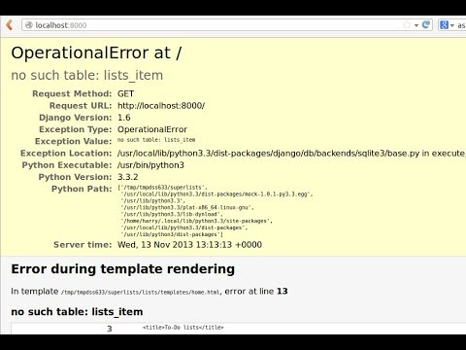

You may have to make the migrations for all tables. Run these commands inside of the “Gamebook” folder:

python manage.py makemigrations

python manage.py migrate

1. **Other Troubleshooting Locations**

Django Documentation

<https://docs.djangoproject.com/en/2.2/>

Python Documentation

<https://docs.python.org/3/>

1. **Contact Information**
2. **Developer Contact Information**

Have any concerns about the project, and want to ask the developers any questions? Here’s our contact information!

Lily

Scrum Master

[lcd64@drexel.edu](mailto:lcd64@drexel.edu)

Khalid

Product Owner

[kjs426@drexel.edu](mailto:kjs426@drexel.edu)

Jarod

UI Designer

[jmd646@drexel.edu](mailto:jmd646@drexel.edu)

Kevin

Game Developer

[kpj28@drexel.edu](mailto:kpj28@drexel.edu)

Jonathan

Game Developer

[jem457@drexel.edu](mailto:jem457@drexel.edu)